**Play with Parity**

There are 2 integers L and R. Let X be the number we get by xoring all numbers in the range [L, R] (including L and R). You recently learnt about even and odd numbers and wonders what will be the parity on X.

**Input Format:**

First line contains 2 integers L and R

**Output Format:**

Print "even" if the number X is even else print "odd" without the quotes.

**Constraints:**

1 <= L,R <= 1018

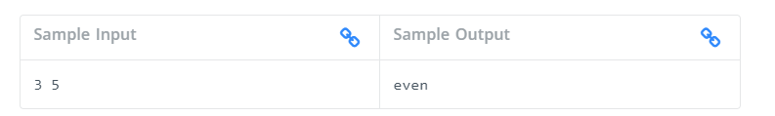

Here L is 3 and R is 5

Now X=(3^4^5) where '^' represents bitwise xor.

X=2.

Since X is even, the output is "even".